David Okech, MSW, PhD
Associate Professor | Director, MSW Program
Director, Africa Programming and Research Initiative to End (APRIES)
University of Georgia|School of Social Work
dokech@uga.edu
The UN Sustainable Development Goals and Human Trafficking: Opportunities and Challenges
This paper is a summary of the interrelationships between human trafficking and the United Nations Sustainable Development Goals (UN SDGs). Specifically, we look at human trafficking as a problem that could be resolved with the attainment of a number of the UN SDGs. Readers are encouraged to situate human trafficking within the glocal (interaction of local and global) social, economic, political, and environmental contexts and to view the anti-trafficking programs and policies within this broader lens. The SDGs are a set of 17 goals adopted by all United Nations Member States in 2015 that provide a shared blueprint for peace and prosperity for people and the planet by 2030. The SDGs recognize that ending poverty and other deprivations must be accompanied by strategies that improve health and education; reduce inequality; and spur economic growth – all while tackling climate change and working to preserve our oceans and forests. Implications for research, programming, and policy are highlighted at the end of the paper.
In “The People, Planet, Prosperity, Peace and Partnership: Why the Sustainable Development Goals Should Matter to Everyone,” Loni (2016) conceptualized how the SDGs could contribute to the improvement of the quality of life for people in the world, including vulnerable and marginalized people. Trafficking thrives on mostly vulnerable children and women. The SDGs derive from the 2002-2015 Millennium Development Goals (MDGs) which had some success on reducing poverty. Unfortunately and unsurprisingly, the MDGs did not address all of the issues that the global environment faced, leading to the need of goals’ reset through the SDGs. On face value, implementing the SDGs clearly offers unrivalled opportunities to advance equal opportunity and foster economic empowerment- helping countries to promote the cause of sustainable development in their territories and benefiting their populations (Leal Filho et al. 2019, 179). This should reduce vulnerability conditions that increase the risks of people being trafficked. Figure 1 illustrates the relationship between some of the risk factors that to the problem of human trafficking.
Figure 1: Human Trafficking Risk Factors and the UN SDGs
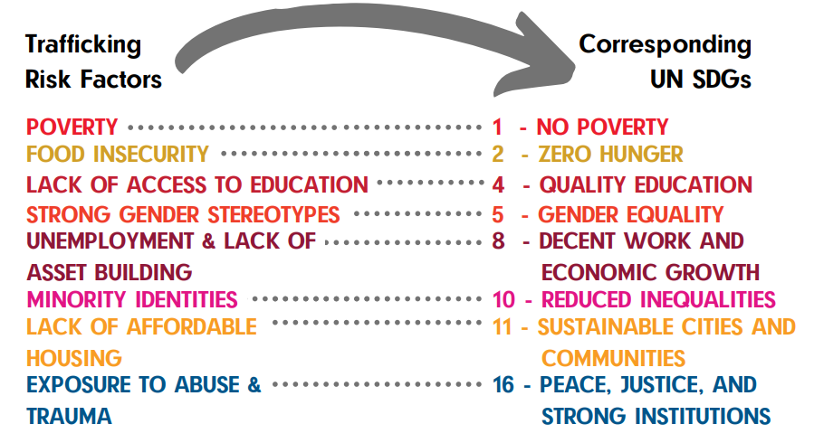
Specifically, SDG Target 8.7 SGD calls on all to “take immediate and effective measures to eradicate forced labor, end modern slavery and human trafficking and secure the prohibition and elimination of all forms of child labor as an essential step to achieving decent work for all, full and productive employment and inclusive and sustained economic growth.” Clearly, anti-trafficking efforts including prosecution of offenders, prevention of trafficking, protection of victims, programming and policy work includes the collaboration of all stakeholders, including governments, social partners, development partners, academia, businesses and others; working together in new and innovated ways to achieve the ambitious and aspirational goals of the SDGs.
Goal 1 of the SDG aims to end poverty in its extreme forms everywhere. Other SDGs that might be important in reducing conditions that would encourage trafficking include: End hunger, achieve food security, improve nutrition, and promote agriculture (Goal 2); ensure healthy lives and promote wellbeing for all at all ages (Goal 3), and ensure inclusive and equitable quality education and promote lifelong learning opportunities for all (Goal 4). Goal 5 is key with its aim to achieve gender equality and empower all women and girls. Others include: promote sustained, inclusive, and sustainable economic growth, full and productive employment, and decent work for all (Goal 8); reduce inequality within and among countries (Goal 10); and make cities and human settlements inclusive, safe, resilient, and sustainable (Goal 11). Finally, Goal 16 calls for the promotion of peaceful and inclusive societies for sustainable development, justice for all, and accountable and inclusive institutions at all levels.
Trafficking is often exacerbated by socioeconomic problems, conflicts, or natural disasters that force people to seek work far from home or to migrate for survival (Sigmon 2008, 246). While some may argue that poverty is not the only risk factor contributing to trafficking, a number of scholars highlight that, in many countries in the Global South, poverty is usually an underpinning factor. Veil (1998) identified forms of child trafficking in Africa demonstrating the effect of poverty as a condition for trafficking. These included payment of sums of money to poor parents who handed over their children on the promise that they would be treated well, bonded placement of children as reimbursement for debt, placement for a token sum for specified duration or for gift items, and enrolment for a fee by an agent for domestic work at the request of the children’s parents. People from poorer countries and families are most at risk of being trafficked, and the rising numbers of the poor and vulnerable enables perpetrators to easily identify and target their victims (Davis 2007, 48; Joshi 2002, 40). This implies that the eradication of extreme poverty (SDG1) would be important in the fight against trafficking, especially given the vulnerability of women and children in sub-Saharan Africa (Moghadam 2005, 16; Smith et al. 2013, 54; Taylor and Miller 2009).
Key to reducing poverty is enhancing access to quality education for girls (SDGs 2, 3, 4, 5, 8, and 10), and enabling them to progress beyond the primary level of education – the minimal SDG requirement – to enjoy access to career and employment opportunities. Given the relationship between gender inequality and human trafficking (Okech, Morreau, and Benson 2012, 490), reduced poverty and increased access to education for girls could promote gender equality and the empowerment of girls and women (SDGs 4 and 5). Further, since trafficked girls are at an increased risk of contracting HIV and AIDS (US Department of State 2014), reducing trafficking might also contribute to reductions in the transmission rates of this and other sexually transmitted diseases (SDGs 3 and 5).
Globalization has increased the mobility of people searching for a better life beyond their countries of origin, and is a known factor in human trafficking, particularly from the Global South, where diminished opportunities for human progress exist (Okech, Morreau, and Benson 2012, 490). For Jones, Engstrom, Hilliard, and Diaz (2007, 108), this is the darker side of globalization that makes poor people vulnerable to exploitation and deception, hence the increasing numbers of people being drawn into human trafficking by unscrupulous traffickers (Davis 2007, 48; Joshi 2002, 37). Global partnerships (SDG 17) are thus key and international covenants and frameworks binding on national governments are needed to combat human trafficking. Macro-economic development and poverty-alleviation strategies are necessary but not sufficient to deal with the complex factors associated with human trafficking (Smith et al. 2013, 54). Development does not guarantee poverty alleviation, especially among the very poor because sometimes development leads to more inequity, thus making the poor even worse off. Still, for some quality of life to improve, socioeconomic development is a precursor. The SDGs are a poverty-alleviation strategy that targets the poorest and most vulnerable in society, while development, more often than not, involves embedding neoliberal macro-economic policies and reducing social spending.
To truly strengthen global partnerships, research needs to be multidisciplinary and cross-national. Research is a major challenge in human trafficking because of the hidden nature of trafficking. In addition, while identifying service and policy gaps in anti-trafficking work is important, the SDGs suggest placing some effort in identifying country-level economic and social priorities, that may in turn, help in reducing trafficking. Research must therefore take into cognizance the glocal factors that actually enhance trafficking not only in each country, but also within particular trafficking hotspots. Trafficking research must go beyond understanding the problem to informing policies and programs.

References
Davis, M C. 2007. "Human trafficking." Hispanic 20 (8): 46-48.
ICAT. “The Inter-Agency Coordination Group against Trafficking in Persons.” 2018. The Role Of The Sustainable Development Goals (SDGs) In Combating Trafficking In Persons 05 (April 2018): 1-4. http://icat.network/sites/default/files/publications/documents/ICAT_Issue_Brief_SDGs%202018.pdf
Jones, Loring, David W. Engstrom, Tricia Hiliard, and Marical Diaz. 2007. "Globalization and Human Trafficking." The Journal of Sociology & Social Welfare 34 (2): 107-22. http://citeseerx.ist.psu.edu/viewdoc/download?doi=10.1.1.851.2214&rep=rep1&type=pdf
Joshi, A. 2002. "The face of human trafficking." Hastings Women’s Law Journal 13 (1): 31-52.
Leal Filho, W., S. K. Tripathi, J. B. S. O. D. Andrade Guerra, R. Giné-Garriga, V. Orlovic Lovren, and J. Willats. 2019. "Using The Sustainable Development Goals Towards A Better Understanding Of Sustainability Challenges". International Journal Of Sustainable Development & World Ecology 26 (2): 179-190. doi:10.1080/13504509.2018.1505674
Loni, Siamak Sam. 2016. “The People, Planet, Prosperity, Peace and Partnership: Why the Sustainable Development Goals Should Matter to Everyone.” Ecodate 30 (1): 7-12. http://search.ebscohost.com/login.aspx?direct=true&db=fth&AN=115210843&site=eds-live
Moghadam, V.M. 2005. “The ‘feminization of poverty’ and women’s human rights.” http://www.unesco.org/new/fileadmin/MULTIMEDIA/HQ/SHS/pdf/Feminization_of_Poverty.pdf (retrieved October 14, 2015).
Okech, D, J Elkins, E Caldwell and M Segoshi. 2014. "Kenya’s new constitution and social development." Social Development Issues 35 (3): 1-15.
Okech, D, Whitney M, and Kathleen Benson. 2012. “Human Trafficking: Improving Victim Identification and Service Provision.” International Social Work 55(4) : 488–503. doi:10.1177/0020872811425805.
Sigmon, Jane Nady. 2008. "Combating Modern-Day Slavery: Issues In Identifying And Assisting Victims Of Human Trafficking Worldwide". Victims & Offenders 3 (2-3): 245-257. doi:10.1080/15564880801938508.
Smith, Bettye P., Tony Lowe, Patricia Hunt-Hurst, David Okech, Emily Blalock, and Alexis Dery. 2013. “The Lifeline Program: A Case Study of Workforce Education Combating Poverty for Females in Ghana.” International Education 43 (1): 50-64. http://search.ebscohost.com/login.aspx?direct=true&db=ehh&AN=92734733&site=eds-live.
Taylor, Gwendolyn M., and Julia R. Miller. 2009. "Beyond Repayment: Micro-credit Lending. A Viable Capacity-Building Strategy among Ghanaian Women." International Research and Theory in Human Ecology 18 (1): 13-20. https://www.kon.org/archives/forum/18-1/taylor-miller.html.
US Department of State. 2014. “Trafficking in Persons Report 2014.” http://www.state.gov/j/tip/rls/tiprpt/2014/ (Retrieved October 14, 2015)
Veil, L. 1998. “The Issue of Child Domestic Labour and Trafficking in West and Central Africa.” Presented at the UNICEF Sub-regional Workshop on Trafficking in Child Domestic Workers, Particularly Girls in Domestic Service, in West and Central Africa Region, Cotonou, 6-8 July 1998.

